Presenting Sponsor:
2024 Sponsorship Opportunity
Flags flown from Memorial Day through Independence Day
PREMIER- $1,000
- 8 Flags in honor of your Heroes
- You or your business name and the names of your Heroes in the Tribute Booklet and the Gazette Journal “thank you” ad
PARTNER - $500
- 6 Flags in honor of your Heroes
- You or your business name and the names of your Heroes in the Tribute Booklet and the Gazette Journal “thank you” ad
SUPPORTER - $250
- 4 Flags in honor of your Heroes
- You or your business name and the names of your Heroes in the Tribute Booklet and the Gazette Journal “thank you” ad
HERO - $50 for each Hero
- 1 Flag in honor of your Hero
- Your name and the name of your Hero in the Tribute Booklet and the Gazette Journal “thank you” ad

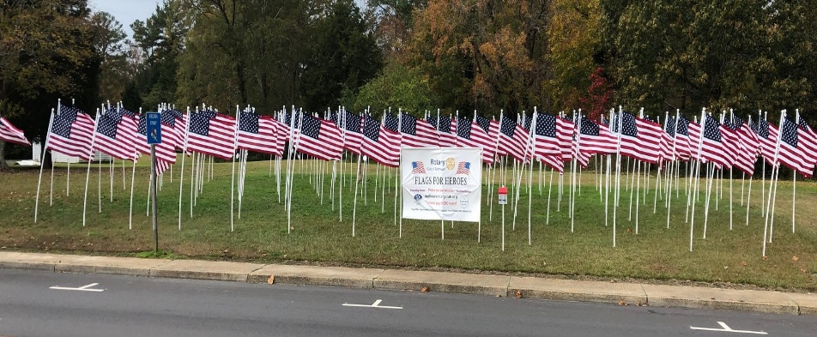
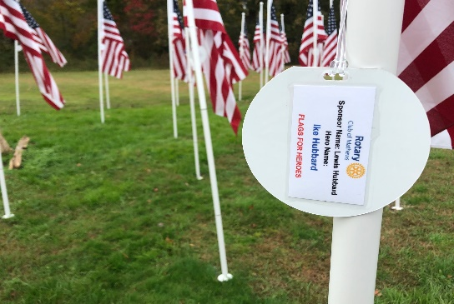
The Tribute Booklet will be published after the event is over. PLEASE furnish an email and/or phone number so we can get this special booklet to every Sponsor. Copies for each and every Hero are provided as well!

